Seesaw Getting Started- Parent’s Guide
What does the Seesaw Interface look like?
The 3 main areas of the Seesaw interface are the Journal, Activities and Inbox tabs.
Journal | The Journal is record of children’s learning over the academic year. It is also an area which children can use to share learning which has taken place outside of school.
Activities | This is an area where teachers post new learning activities.
Inbox | Teachers will post whole class and individual messages directly to children via the inbox tab.

____________________________________________________________________________________
How to Respond to an Activity
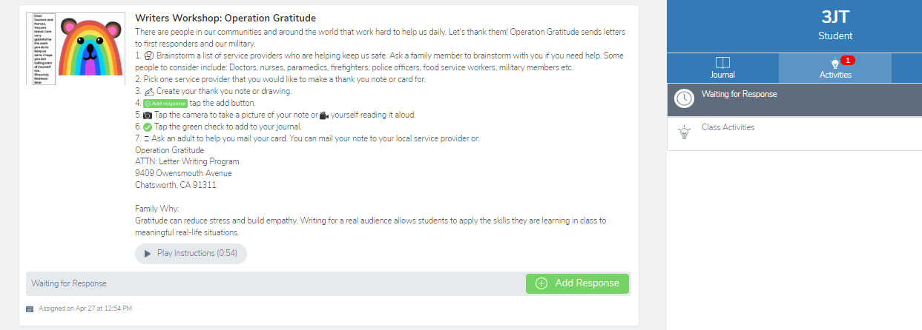
Step 1: Click on the green ‘Add Response’ button
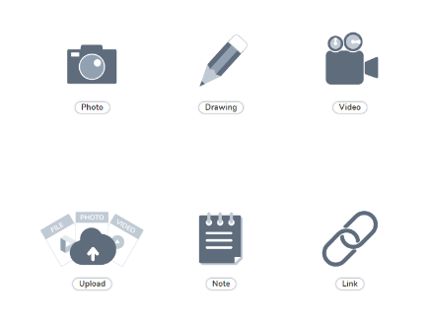
Step 2: Choose a Seesaw tool to respond to the activity.
Sometimes teachers will request that children use a specific tool to complete the activity (for example the drawing tool) or provide children with a template to add answers. The tools are used to support children’s creativity.
Step 3: Use the Creative Tools to respond to the activity.
Step 4: When you are finished click on the green tick.
The work is now automatically uploaded to the teacher’s folder and awaiting a response.
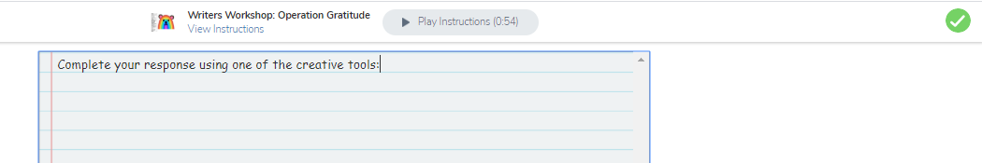
What are the creative tools?
Tool | Description
The photo tool allows children to take pictures of their work. When you tap the photo tool you will be able to take a photo using your device to add directly to Seesaw. Make sure you "allow" camera access when prompted!

You can use this tool to:

- Add images of children work
- Document experiences
- Simultaneously draw and record audio
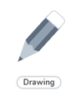 | The drawing tool allows children to create digital artwork. When you tap the drawing tool you will be shown a blank canvas on which to create your work. There are a variety of drawing, photo and labeling tools as well as a full rainbow of colors to choose from.  You can use this tool to:  - Simultaneously draw and record audio  - Add a photo collage  - Show what you know  - Add backgrounds and shapes using the ... tool  - Create art with expressive pens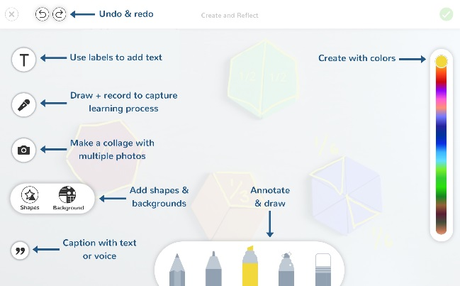
The video tool allows children to take videos. When you tap the video tool you will be prompted to "select or drop a file" or "record a video"! This means children can upload an already created video OR record one live to add to their journal.

You can use this tool to:

- record reflections
- document experiments
- create tutorials for other children
- Showcase children’s reading skills
 | The Link Tool allows you to add links. When you tap this tool you will be prompted to paste a link that you have saved to your clipboard.
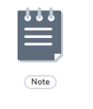 | The Note tool allows you to write and publish text notes. When you tap this tool you will be shown a lined page to type your thoughts on.  You can use this tool to:  - write a reflection  - send an assignment or prompt to students  - create journal entries
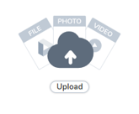 | The upload tool allows you to add files. You can connect Google Drive to easily add files and slides directly from the drive.  You can use this tool to:  - Upload and annotate items from Google Drive  - Add files to annotate from your computer to Seesaw

For further support please refer to the Seesaw website:
https://help.seesaw.me/hc/en-us

